1. **PROJECT INTEGRATION MANAGEMENT**

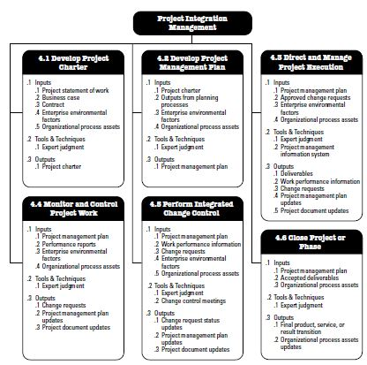

1. **PROJECT SCOPE MANAGEMENT**

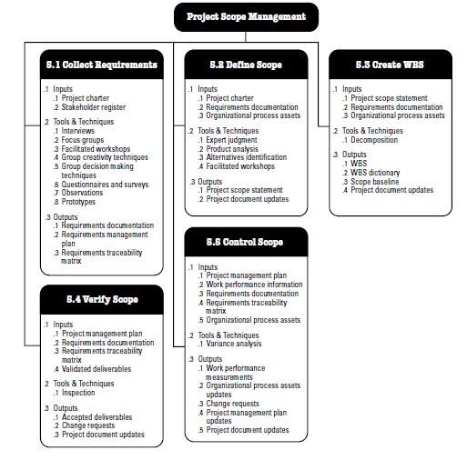

1. **PROJECT TIME MANAGEMENT**

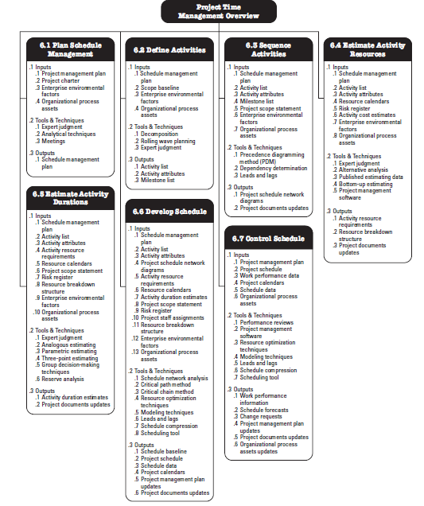

1. **PROJECT COST MANAGEMENT**

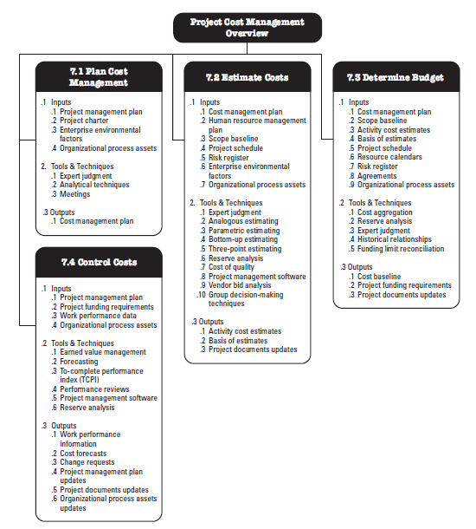

1. **PROJECT QUALITY MANAGEMENT**

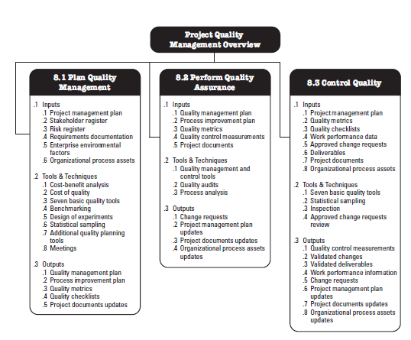

1. **PROJECT HUMAN RESOURCE MANAGEMENT**

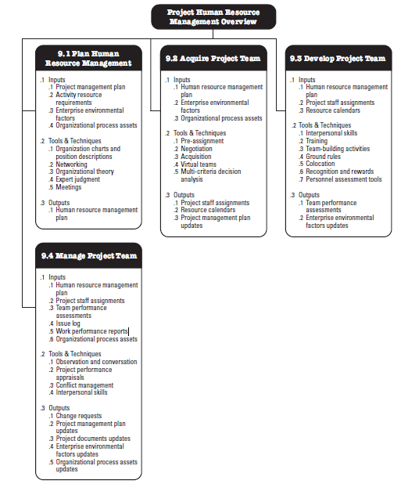

1. **PROJECT COMMUNICATIONS MANAGEMENT**

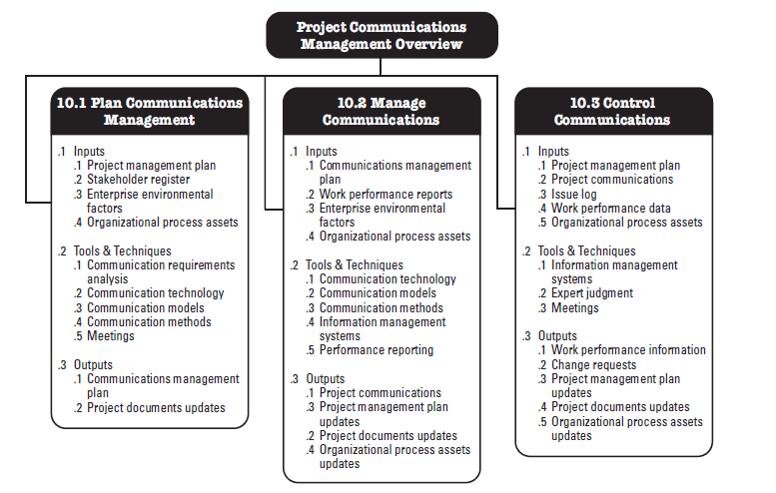

1. **PROJECT RISK MANAGEMENT**

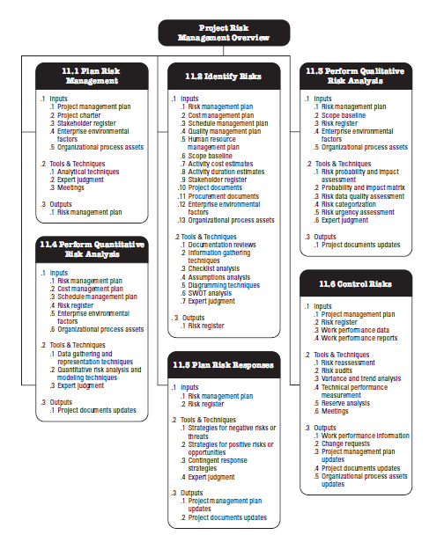

1. **PROJECT PROCUREMENT MANAGEMENT**

